[Index.php](https://jupiter.csit.rmit.edu.au/~s3871704/mp)

[Facilities.php](https://jupiter.csit.rmit.edu.au/~s3871704/mp/facilities.php)

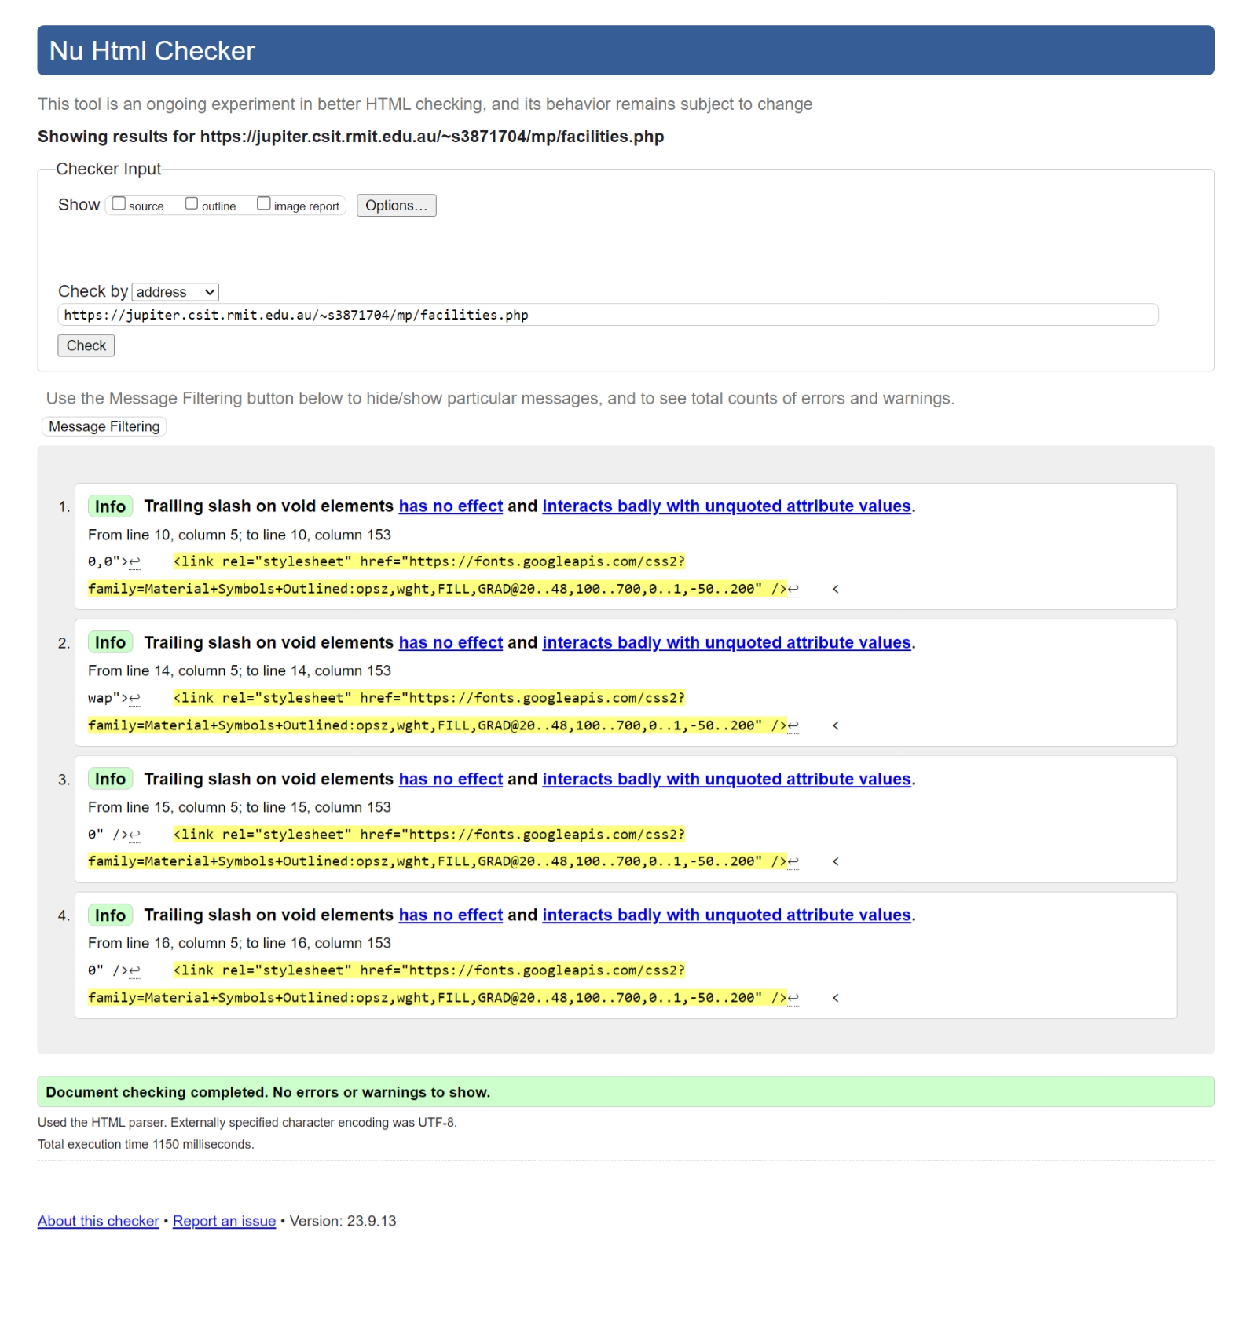

[Gallery.php](https://jupiter.csit.rmit.edu.au/~s3871704/mp/gallery.php)

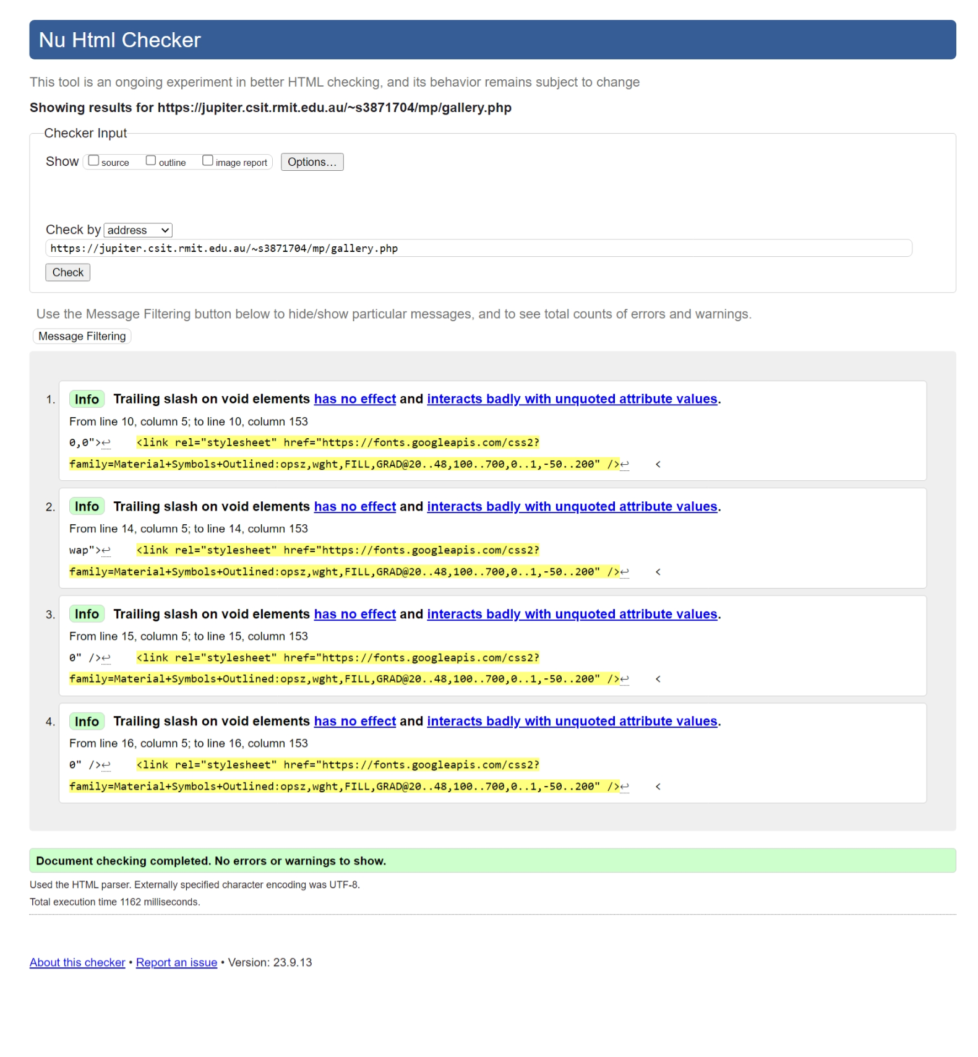

[add.php](https://jupiter.csit.rmit.edu.au/~s3871704/mp/add.php)

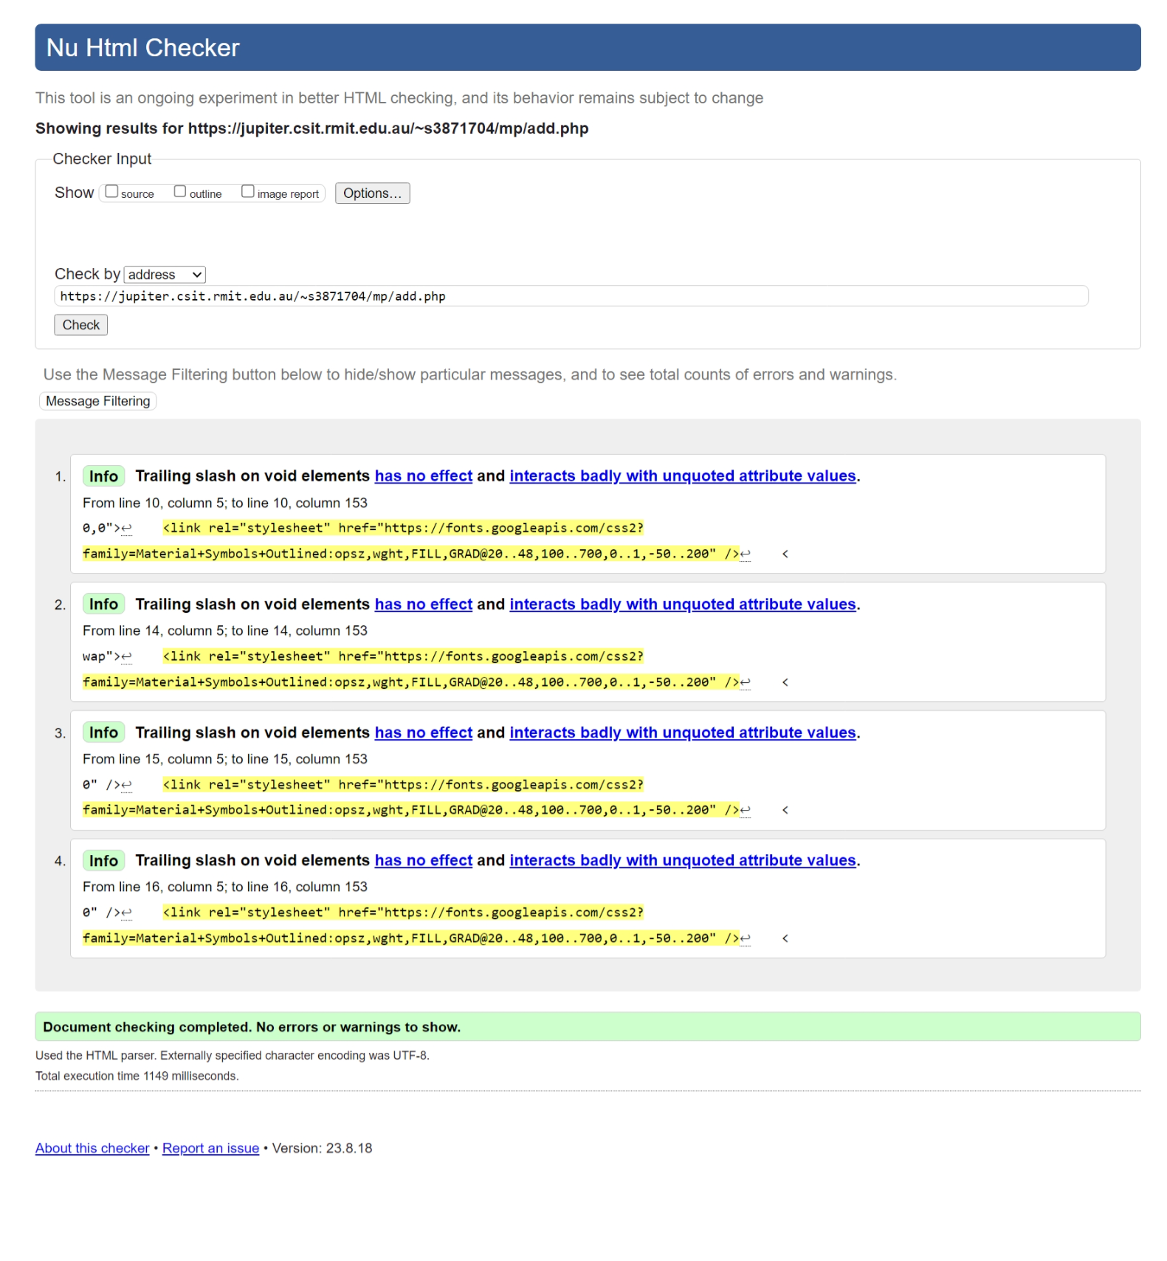

[Facility_detail.php (a random id)](https://jupiter.csit.rmit.edu.au/~s3871704/mp/facility_detail.php?id=27)

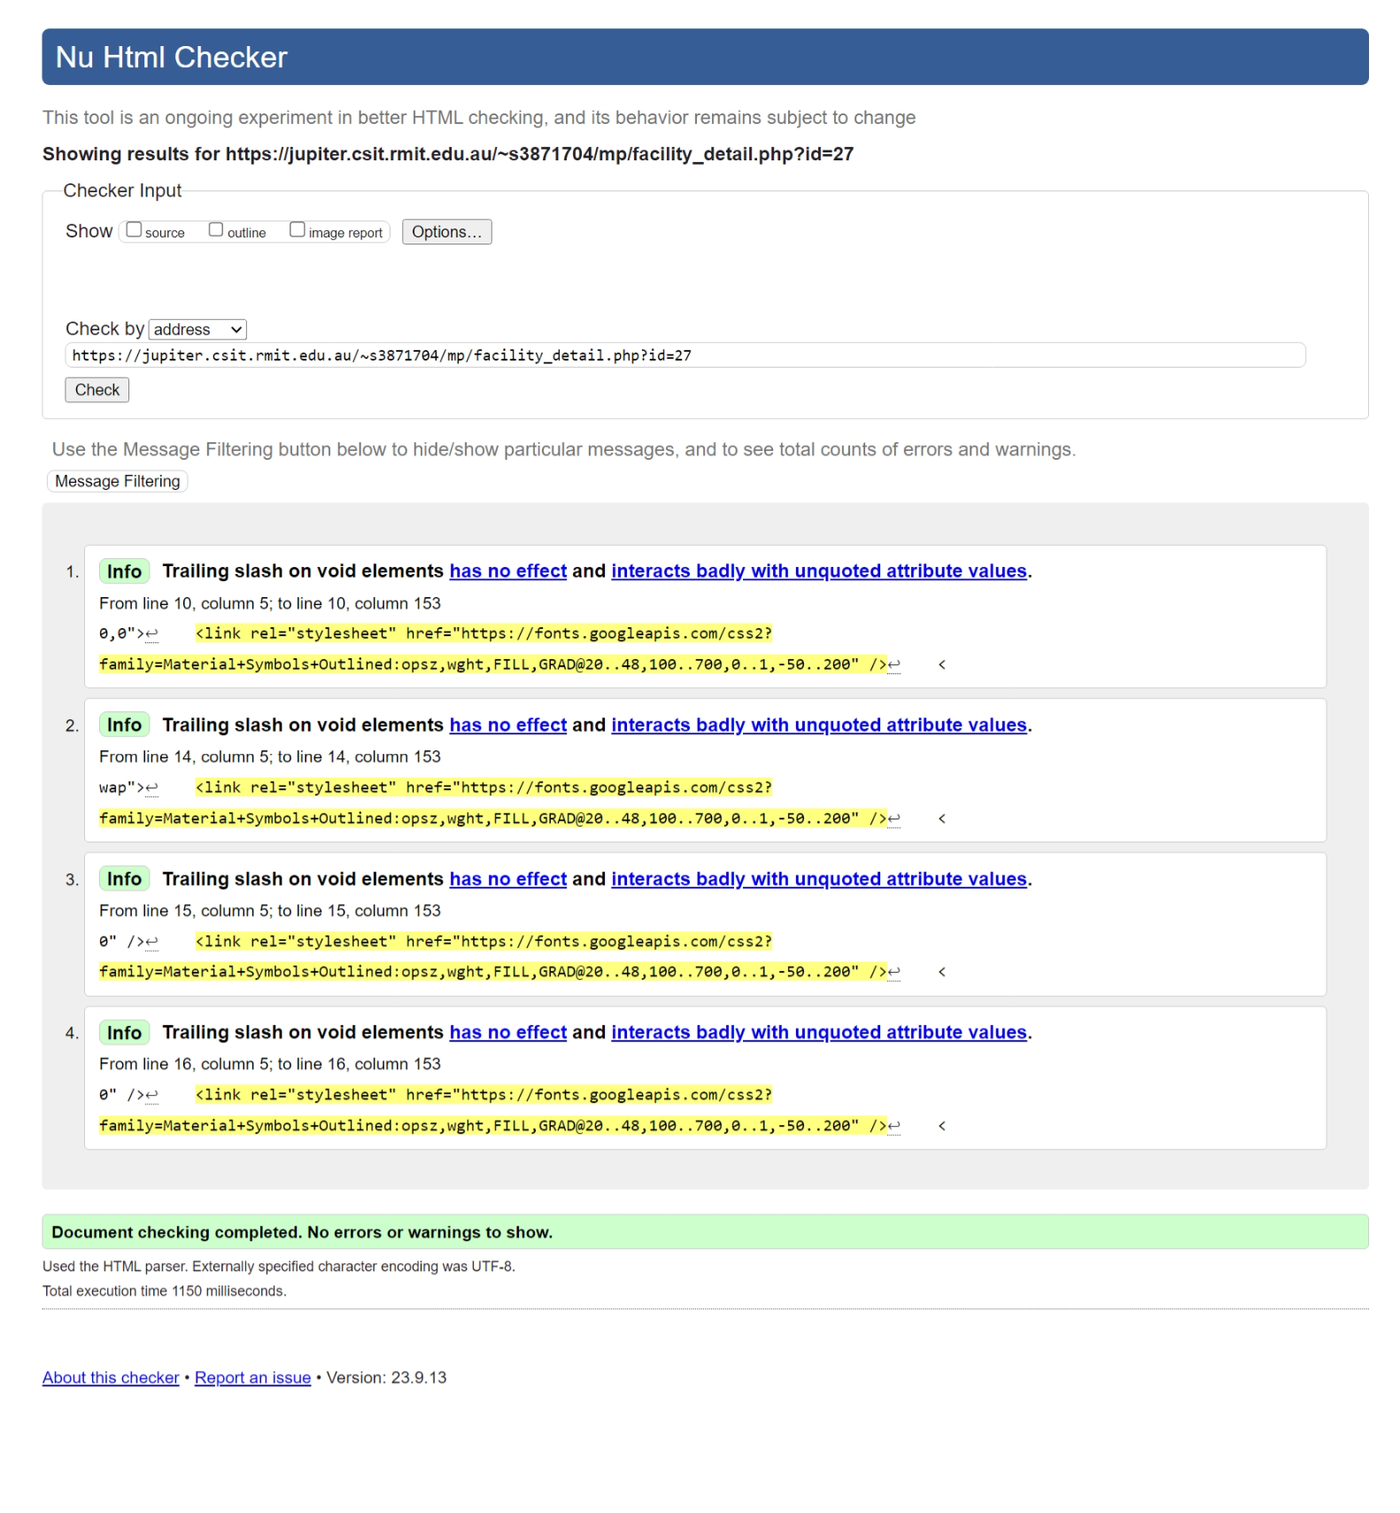

Style.css

[Register.php](https://jupiter.csit.rmit.edu.au/~s3871704/mp/register.php)

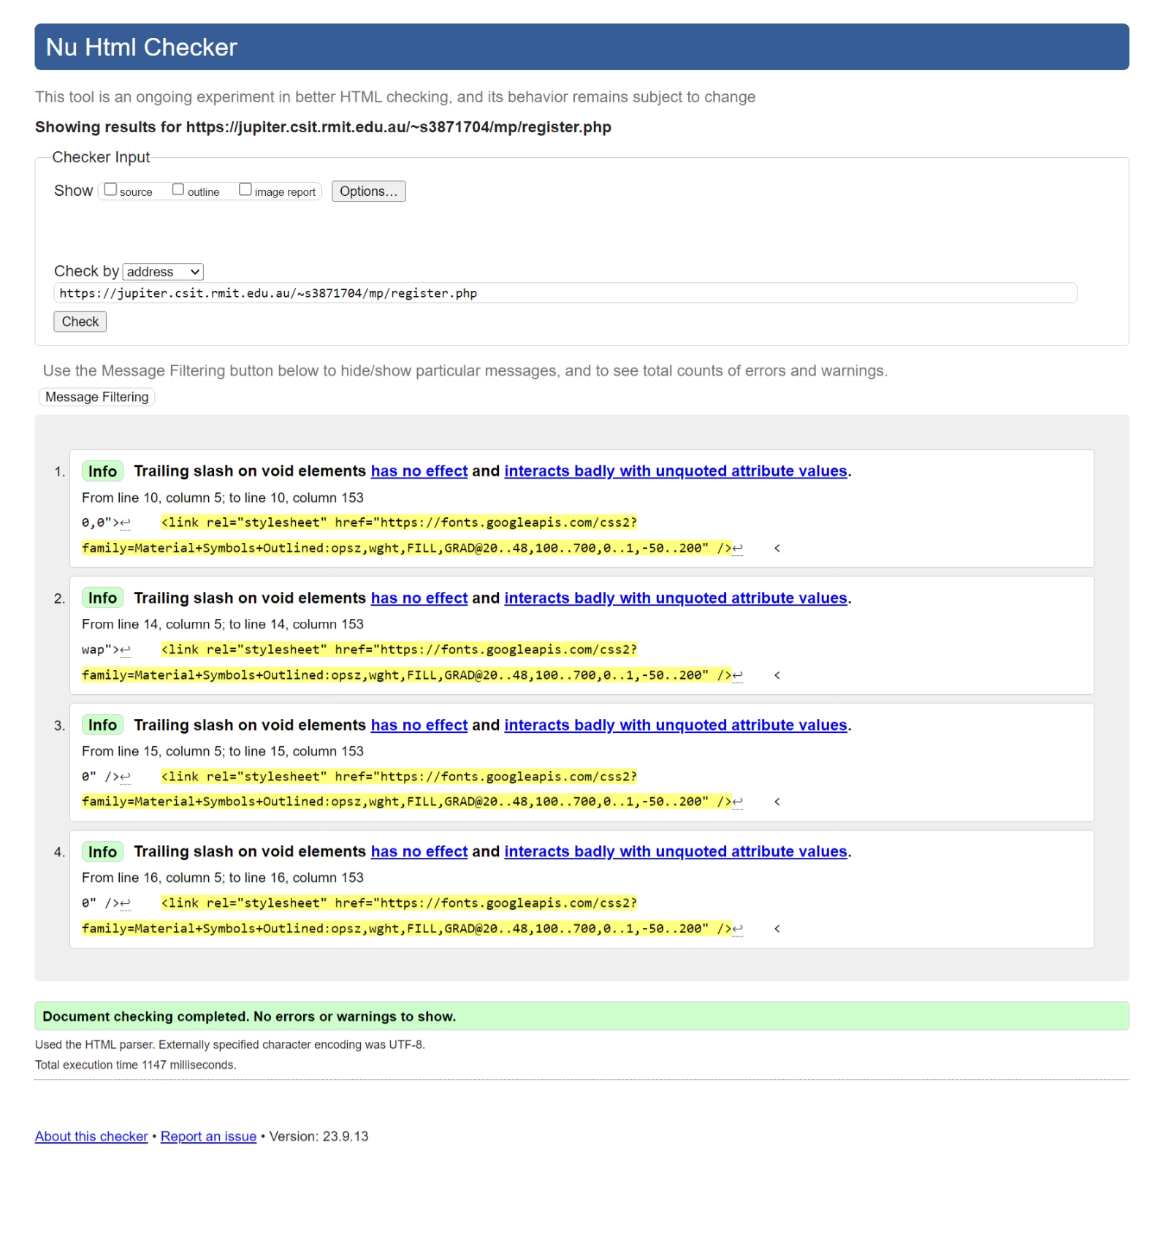

[Login.php](https://jupiter.csit.rmit.edu.au/~s3871704/mp/login.php)

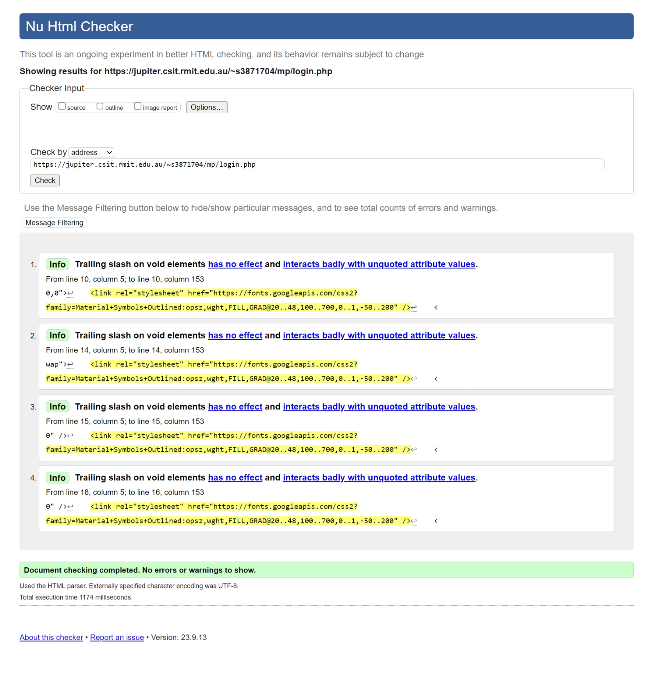

[User_collection.php](https://jupiter.csit.rmit.edu.au/~s3871704/mp/user_collection.php?username=Minh) <random logged in user><need to be logged in before running validator>

<usr:Minh-pswd:1>

Edit.php <random facility id> <Need to log in as facility author to access>

<usr:Minh, pswd:1, facID:32>

